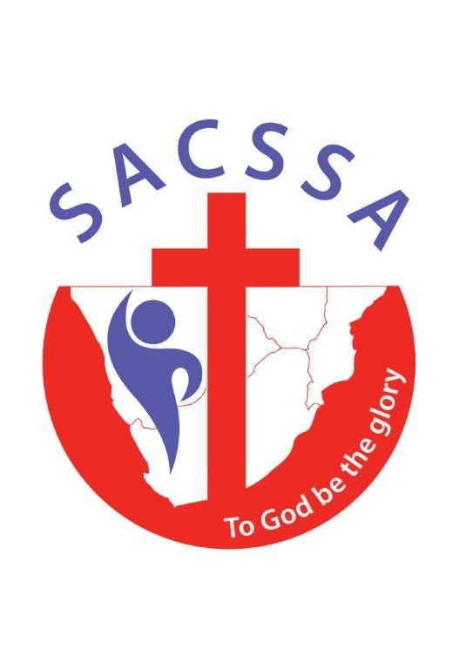
THE
SOUTHERN AFRICAN
CHRISTIAN SCHOOLS’ SPORTS
ASSOCIATION

034-141 NPO

Postnet Suite 273
Private Bag X5091
Brits, 0250

Fax: 086 502 8664

Cell: 082 563 8519 [Johan]

E-mail: johan@sacssa.co.za


3 August 2026

Regional Co-ordinators

Please forward to all your schools. Thanks

Dear Principal and Cross Country Co-ordinator

SACSSA NATIONAL CROSS COUNTRY REPORT AND RESULTS

With 281 athletes entered for the SACSSA National Country, at Caritas School, in Bethlehem [FS], on Saturday 1 August, we had an excellent SACSSA National Event..

Our sincere appreciation to Gert Heymans and Warren Jarm, from the Free State, who did all the organizing.

Our appreciation to aQuellé for their sponsorship, for water for all the Officials and Athletes and their display of all the banners.

To all the officials, who worked so hard, we would like to extend a special word of appreciation.

We encourage all the Regions to make a huge effort in future to send athletes to this excellent event, as it is also seen as a very important pre-event for the SACSSA Athletics

Individual Age Group Results
The Full Results are included.

Team Results
Congratulation to Kwa Zulu Natal, who won all 5 categories:
- Junior Girls
- Junior Boys
- Senior Girls
- Senior Boys
- Overall Winning Region.

SACSSA Certificates

Apart from the medals that were awarded to the top 3 finishers in every race, schools are welcome to order a Merit Certificate for the Top 3 athletes, or a Participation Certificate for any of the other athletes.

SACSSA National Colours
All the athletes who ran within the Qualifying Time [see attached] and finished in the Top 3 Positions, may order SACSSA National Colours.

The SACSSA National Colours consist of the following:
- SACSSA National Tracksuit
- SACSSA National Vest
- Honour Scroll

To Order
Included, please find the SACSSA NATIONAL COLOURS – ORDER FORM

Should the athlete wish to place an order, the Order Form must be completed in detail and returned directly back to the SACSSA National Office, to johan@sacssa.co.za on or before Monday 10 August, with a copy to your own Regional Office.

Unfortunately orders coming in after Monday 10 August, cannot be processed.

Payment
Prices for the different items are given on the Order Form.

Unfortunately no orders can be accepted without full payment.

Payments must therefore be done at the same time that the order is placed.

All payments must be made, as one amount per school, directly into your own Regional Account:

As reference please put CC Colours and School Name. The proof of payment must be sent to your Regional Office.

Finally
Thank you for all the effort that you are putting in, in lifting the standard of SACSSA Cross Country.

This includes your effort to instil a sense of commitment in all your sports people.

As Cross Country can be seen as the basis of all sport, in the sense that it concentrates on basic fitness, we are looking forward in seeing what effect these results will have on our Athletics.

Should you have any further questions, please do not hesitate in contacting me.

SACSSA 4 LIFE

Johan du Plessis
SACSSA National Co-ordinator

